ANGULAR HANDS ON 9
State Management — NgRx Store, Actions, Reducers, Effects & Selectors

Student Course Portal Application

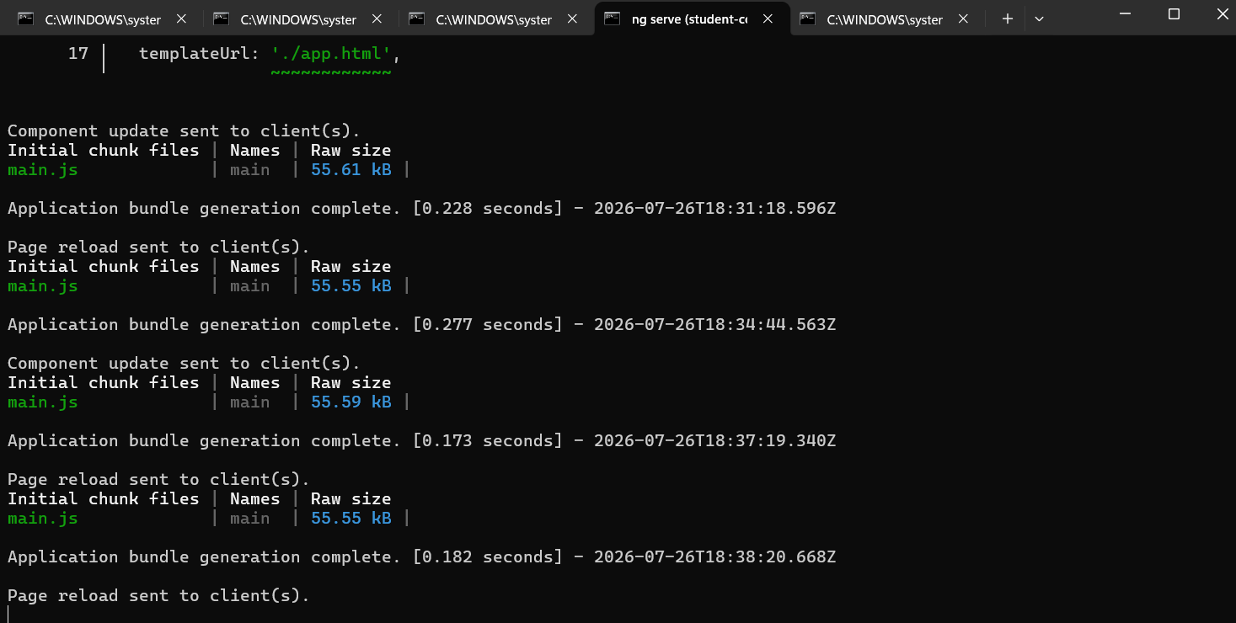

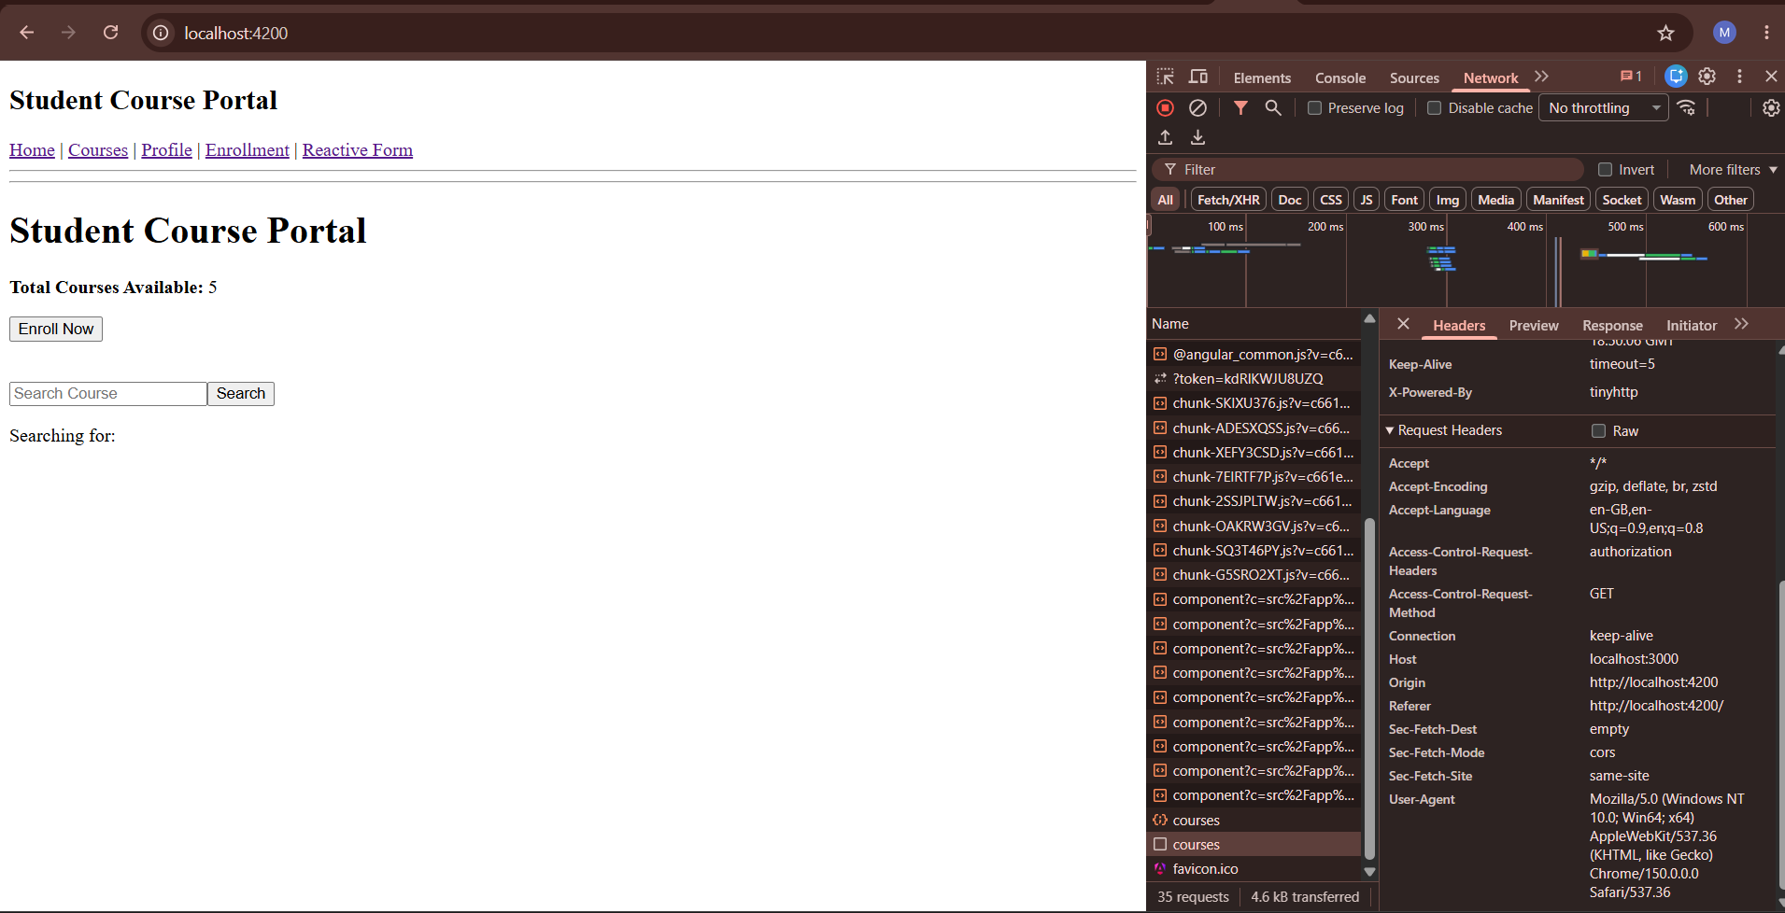

Objective
To understand the concepts of State Management in Angular using NgRx Store, Actions, Reducers, Effects and Selectors for managing application data efficiently.

Description
NgRx is a state management library for Angular applications based on the Redux pattern. It helps maintain a centralized store where application state can be managed, updated and accessed in a predictable way.

Concepts Covered
• Store - Centralized location for application state.
• Actions - Events that describe state changes.
• Reducers - Functions that update state immutably.
• Selectors - Functions used to retrieve data from the store.
• Effects - Handles asynchronous operations such as API calls.

Current Application Output
The Student Course Portal application was successfully developed using Angular. The application displays course information, handles user interactions and retrieves course data through API integration.

Result
The Angular application was successfully executed and the expected output was verified.

